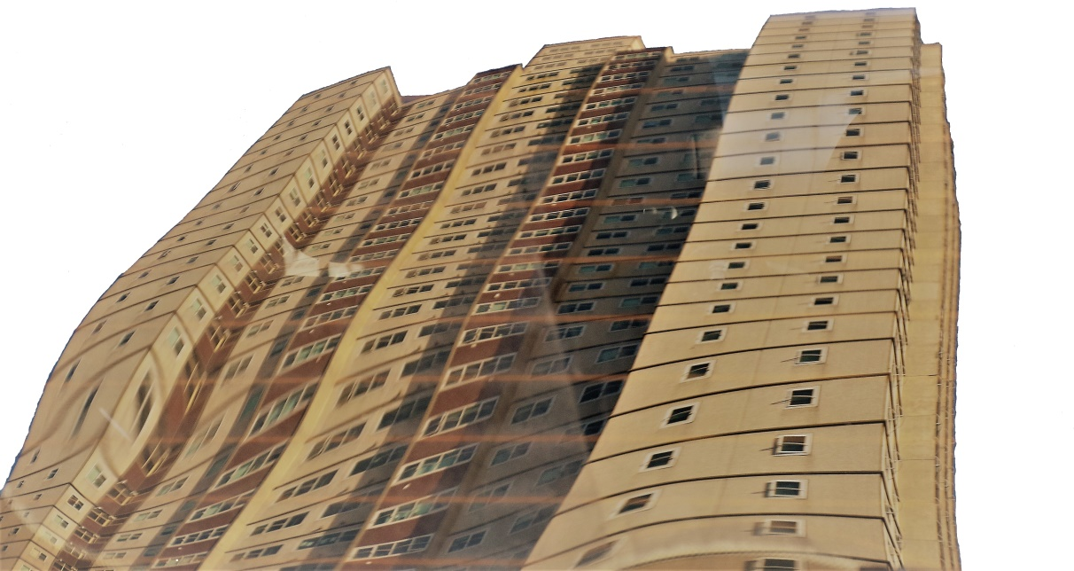
OFFICE BEARERS 2018
President : John Lowndes
Secretary : Felice Vaiani
Treasurer : Maria Szatmary
Committee members:
Kimberly Bonilla
Schlomo Nathanson
OFFICE HOURS:
Mon-Thurs : 10am-1pm
Friday : 10am-12pm
DEAR TENANTS,
Park Towers Tenant Management Inc. hopes you all had a Merry Christmas and a Happy New Year. We have been in office for a year now and are very pleased to be staying for 2018. We also welcome to the committee Schlomo Nathanson, who is a new member following the retirement of Nick Hearnshaw. Remember to stay cool and stay hydrated over the holiday season. We look forward to seeing you soon!
Park Towers melts due to the sweltering summer heat
T E N A N T

Park Towers Tenant Management Inc. Newsletter Jan 2018

IS PARK TOWERS BAD ENOUGH YET?
IF YOU CALL “000 POLICE “WILL THEY COME TO PARK TOWERS?

It is common knowledge that most cases of vandalism and crime on the Park Towers estate happen during the day because we don’t have day time security guards. Whenever a request has been made for daytime security services, the Office of Housing has said Park Towers is `not bad enough yet´ to have day time security.
However, recent events beg to differ from this viewpoint and prove that there is cause for concern. There is a gang that now roams the building robbing people by knife point according to Victoria Police, who reported that these attacks having resulted in people being stabbed.

Does life threatening violence count as bad enough?

On top of this I know from personal experience that calling 000 and asking for police to attend doesn’t mean they will come.
It is not rare to get a call back from 000 dispatchers and to get asked if you really need the police to attend.

I’ve also have heard anecdotal accounts from other tenants having called the police and having asked them to attend their flat to which end no police arrived.
The main reason police don’t bother to show up is that by the time they get here the perpetrators have usually scurried off because we don’t have day time security that can attend the scene of crime until help arrives.

Of course, if we were not public housing they would arrive in a heartbeat. There is a mentality that puts the blame on tenants for living in public housing, I was at a meeting about “crime and safety”, held by the OoH and the police where a senior OoH officer told the audience of mostly elderly woman that if they were too afraid to live in public housing they could always move out into the private sector.

That is not to say that our very good South Melbourne Police are not doing their best to crush this appalling violent gang. They are, but without essential day time security services criminals can easily escape. You may have seen the letter from Victoria Police in the showcase in the foyer of which we have attached a copy to this article.

PTTM are writing to our local member Martin Foley MP who is also the Minister for Housing to request that he insist on providing day time security. We want it and South Melbourne police want it. Sign our petition in the office which is open on Fridays from 10am or please email your demand for day time security to martin.foley@parliament.vic.gov.au and the Minister for Police lisa.neville@parliament.vic.gov.au and us at pttm.inc@gmail.com
If you don’t have a computer, remember the computer room is open from 10am to 12pm Monday to Friday.
John Lowndes __________________________________________________________________________________
THE HON MARTIN FOLEY MP OPEN LETTER
Minister for Housing, Disability, Ageing,
Mental health, Equality, & Creative Industries
Level 22/50 Lonsdale St.
Melbourne VIC 3000
Martin.foley@parliament.vic.gov.au pttm.inc@gmail.com
19 December 2017

Dear Martin,

As promised at your Xmas party, I’m writing to you in regard to the lack of day time security at Park Towers, as you now know the police are having big problems putting an end to gang violence at Park Towers.
The department has always told us that we are not bad enough yet to have daytime security, an appalling and outrageous thing to say but that is how the OoH works. Not until someone dies in a fire or a block of public housings flats burns down as in London does anything happen. Ongoing maintenance is not attended to, instead something has to break down completely then it will get fixed.

Every time I ask now about the possibility of having daytime security I get told it will never happen as there is no money for it. Yet you see the department wastes so much money everywhere else it’s staggering.

It’s ironic that at night when we have 6 guards there is less crime, vandalism and violence than during the day.
I pointed this out in an article in our upcoming newsletter where this letter will also be published, how many people have to be robbed at knifepoint or stabbed.

PTTM Inc proposes 4 daytime guards as patrolling is easier during the day light, that would mean that at all times there would be 1 guard at on the real time monitors, 2 guards walking the floors and 1 floating covering breaks, lunch and patrolling the grounds.
This would save so much police time and enhance police’s effectiveness, save money on damage to the buildings and rid us of dangerous tenants.
As you said at your party when I showed you the letter from Victoria police, ‘’it's time’’ and it is we look forward to daytime security in the New Year.
Regards
John Lowndes
President PTTM.Inc

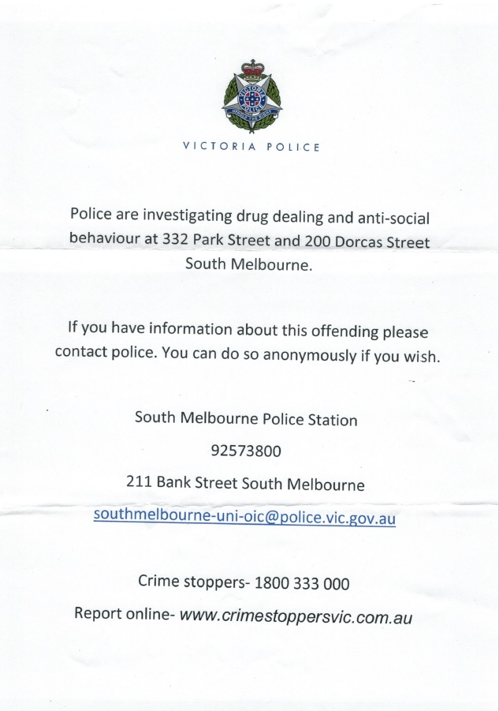

HOW PARK TOWERS MISSED OUT
ON CHEAP AND CLEAN ELECTRICITY

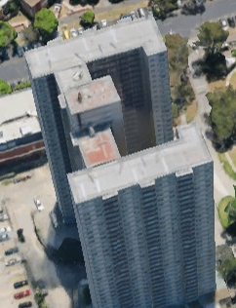
In 2016 when I was first elected as chairperson of Park Towers Tenant Management, one of my main goals was to modernise the way we do things. As we all know, one of the most important industries in the 21st century is renewable energy. I decided to search for a deal with a solar energy provider to place solar panels on the roof to feed energy to the building; to the benefit of tenants, the environment and the Office of Housing.
I came across a social enterprise called Allume. They offered us a solar energy install and buy back deal in return for advertising their enterprise on top of the building. I contacted our local member and the Minister for housing Martin Foley MP. I have attached a letter I wrote to him on the topic. In a face to face meeting he said it was a great idea and that he would contact the local OoH office in order to arrange an inspection of the roof with myself and a representative of Allume. In a matter of days the entire plan was crushed. Why?
Park Towers rooftop was proposed as a sight for solar panel installation
A senior housing representative boasted about being on the alternative energy committee at the OoH, but so far the committee has only delivered talk with no action. I was accused lying about the minister's approval of the whole idea.
The truth is that there have been plenty of new maintenance staff who have been taken up there for years to look at the view by DHHS.
The Minister also thought that my idea of selling advertising space on the top of the building during the grand prix, it would have raised conservatively $40,000 for PTTM, however his staffers and the OoH said you could possibly have advertising on a public building., really well it seems it’s ok to have advertising all over a public park that the Victorian government subsidizes to the amount of $50,000,000.
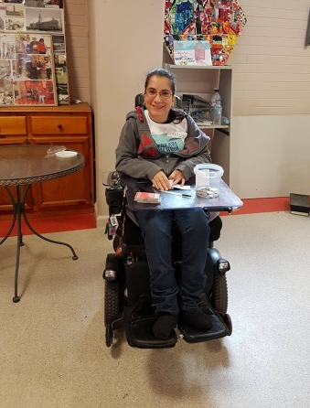
In the end, Allume went on and installed solar panels. They installed them on to the rooftops of a block of 92 privately own flats in Fitzroy and many others since. Once again public housing lives in the dark ages due to poor political and public service management. This is clear proof of the inability of those in authority to make a decision and achieve an outcome. .Park Towers Tenant Management Inc. is determined to make changes that will benefit our tenants and even the OoH despite political timidity.
John Lowndes
KOLORFUL K9S FOR KIDS WEEK
On Saturday October 21, PTTM Inc. hosted their first community event, Kolorful K9s for Kids Week. The event would not have been possible without the Small Poppy Neighbourhood grant from the City of Port Phillip and our partners - Arts Access, Bunnings Port Melbourne, Victorian Ambulance Museum. The children loved getting glitter tattoos, playing with Marshall from Paw Patrol, face painting, having a look at the firetrucks and ambulances and building mini buildings and structures out of cardboard and paper. Frank’s private Fire Engine collection was a big hit with attendees and volunteers did a great job. Canines were able to get a doggy makeover with Jan at the Bow Wow Beauty Salon and guests could enjoy delicious paella from Simply Spanish, vegetarian treats from Cafe Pixxina or a sausage sizzle.
Overall, it was a wonderful day and we thank everyone that helped out.
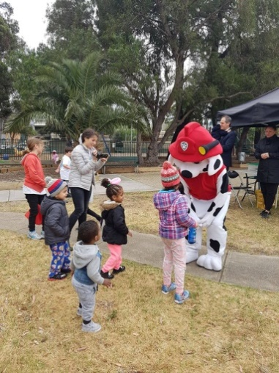
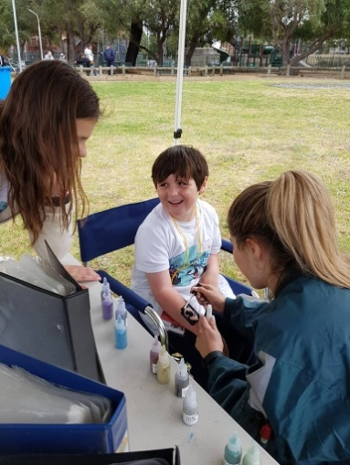
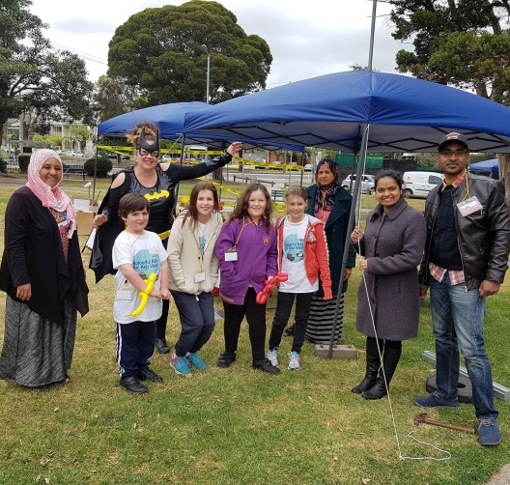
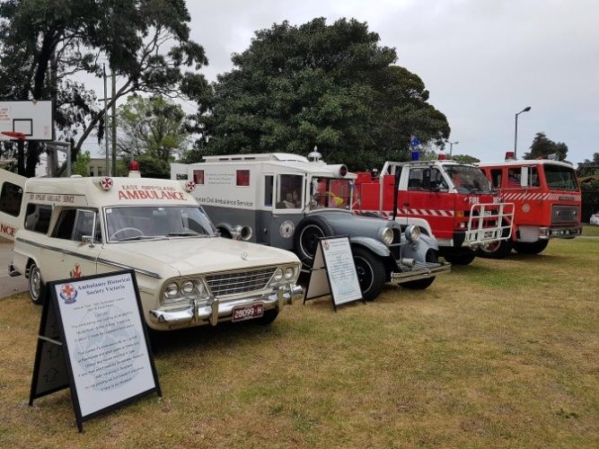

NAUGHTY SANTA CAUSES
BUREAUCRATIC STORM OF HYPOCRISY

Even though Felice and I are not Xmas people we promised Maria that we would make an effort to put up some kind of Xmas decorations.
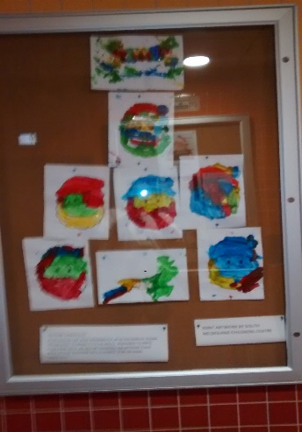
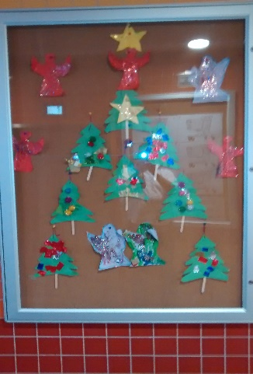
So I placed a flashing star in our new office window and requested some drawings from the children at our child care centre, which were very sweet.
I thought we all needed something to make us smile, if not laugh, and so I thought of different images of Santa. There were a number of hilarious, silly and funny Santa’s, such as Bad Santa, Naughty Santa, Thirsty Santa, Patient Santa and Park Towers Santa.
On the day they were put up in the newly installed info boards, I received a call from the South Melbourne OoH ordering me to take down Naughty Santa as one tenant had rang and complained about it. Just one! Of course I refused as there over 800 tenants at Park Towers so even if it was 20 tenants it would not represent even 3% of the population.
The OoH said Naughty Santa was “offensive and below community standards’’. Of course this was not only ridiculous and completely untrue, but is also an example of outrageous hypocrisy.
If only one tenant’s complaint would be taken into account when it came to complaining about the appalling filthy state of the building! Graffiti is on many walls, floors and in the stairways of Park Towers. Offensive and puerile images of penises and words such as F*** and C*** as well as sexist, racist and misogynistic slurs adorn the building. Parks Towers could be a museum of contemporary obscenity. The perpetrators – or artists - are drug addled people (drug dealing tenants and their clientele) loitering about the building terrorising young and old alike.
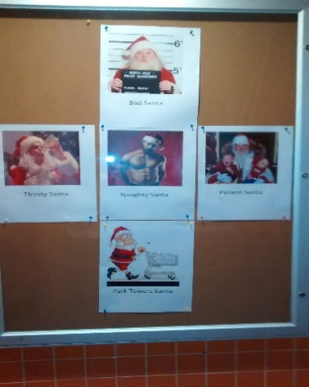
If this behaviour of people urinating and defecating everywhere, gang members brandishing knifes and holding tenants up and yes stabbing them, doesn’t warrant action but a photo of Naughty Santa does, then the OoH’s priorities, its regard for us and our welfare seriously has to be questioned. As does their credibility and their ability to manage anything or anyone.
I find this entire ordeal very offensive and below community standards, I’m sure you do too.
But was taking down all the Santa’s the end of this Christmas Carol?
A housing official rang me at the end of the day telling me that the number of complaints had doubled to a total of two. I got threatened personally and told that our funding would be cut and the Tenants Association would be dissolved.
Well, for a start you cannot just cut off funding it’s actually a very detailed process which they would lose. Also, we are independently incorporated non-profit so he could not dissolve PTTM Inc. Moreover, if he tried to take away our grant, offices, computer room, recreation room or PT reserve they would have a very long fight on their hands via VCAT as there is a 20-year precedent that has been set.
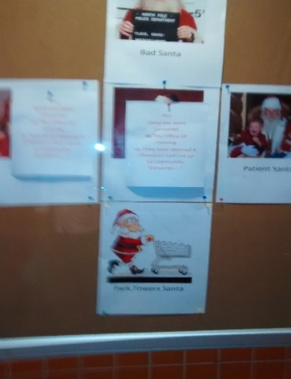
They also started verbally wringing his hands in hysteria when I told him about thirsty Santa which no one had had a problem with until then.
They said there may be alcoholics in the building. I think they meant that looking at Santa swigging a 5th of vodka may cause them to get upset to drink, really?
This notion then sent them into new hyper hysteria, “What if the media get hold of it?’’. Well, if the media were not interested in the 24th floor fire were people almost lost their lives until a public housing block burned in London with appalling loss of life naughty or thirsty Santa will not be likely to evoke the outrage of the tabloid media.
I covered up Naughty and Thirsty Santa with pieces of paper stating “Santa was censored by the Office of Housing”.
The next morning the local OoH was told to rip down all the Santas.
What I wrote on the pieces of paper was the truth. It was a political act, thus the OoH cannot stifle or threaten any such messages or debate in the common areas of the building.
Putting us down was of course against the Victoria charter of human rights and responsibilities. I have said in the past that I will not allow people or representatives of the OoH to treat us like this.

John Lowndes

CONCERNS FOR OUR SAFETY
On January 22nd two young women and their children were the ones to notify Secretary Felice Vaiani that all three lifts were sprayed with blood. Mothers, children and the elderly had to deal with a horrific crime scene because of a violent brawl that began in broad daylight. Had there been daytime security, the ordeal would have been dealt with much sooner.
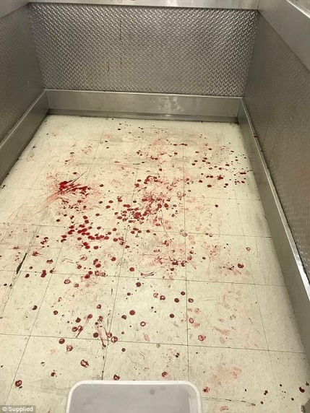
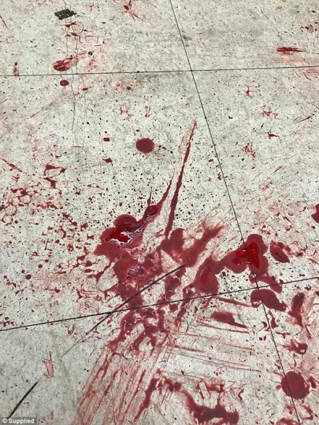
There was an hour gap between 4:30pm-5:30pm, when the first report was made to the office to when ambulance and full police backup arrived. Within that time an old man was man handled and smeared in the blood of the perpetrators and a shirtless suspect ran out of the building covered in blood.
Park Towers has an urgent need for support from housing officials when it comes to safety. Residents, now more than ever, do not feel protected. More than one mother has told me that they do not feel comfortable raising their children in the building because they do not feel safe. As tenants of public housing we rely on the OoH to take our concerns seriously.
As it currently stands, OoH failed the tenants of Park Towers with their lack of foresight and planning for emergency situations. On the day of the ordeal a representative did not arrive until 6:30pm. We need an emergency number through which to contact the housing office at the very least. We have not been provided with an emergency procedure nor do we have access to the public address system to notify tenants to remain in their homes.
Tenants were stranded in the foyer when the lifts were shut down. For the most part they consisted of families with children and the elderly, with one woman nursing a plastered arm.
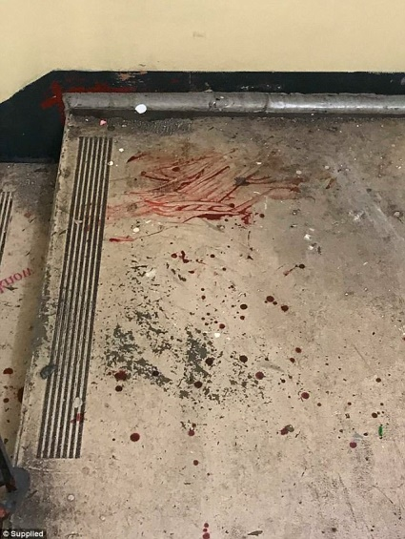
Numerous times, we have pleaded for daytime security because we know they could contain and prevent a situation such as this from spiralling out of control. There has been no effort to come up with alternatives in response to our safety concerns. I wrote about our need for daytime security to help avoid situations such as what happened on January 22nd in the previous newsletter. Not only could this have saved the trauma of residents, but it also would have meant that there was not a line of 50 tenants at 8pm waiting to use the only functioning lift.
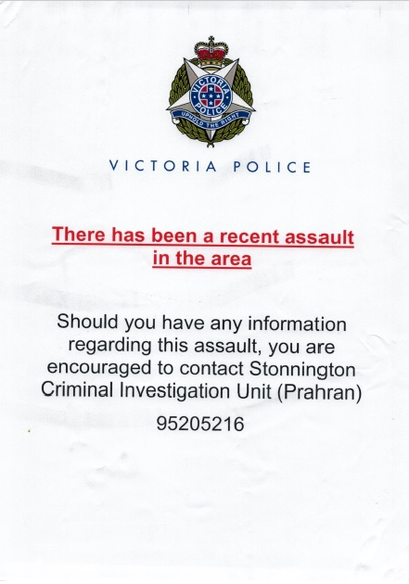
The unruly minority in the building who perpetrate violence and crime are being permitted to do so. Their wrongdoing is supported through inaction.
If the OoH acted after two tenants complained about an image of naughty Santa in the foyer, then that is fair enough. But I would like to ask what about the 68 residents that have signed a petition calling for daytime security?
PTTM Inc. is planning a public meeting with tenants and officials to discuss our safety concerns and crime prevention. It will be a great opportunity for tenants to directly express their thoughts. Tenants should feel free to visit the office for more information. Hopefully action will be taken now that blood has already been shed.
Kimberly Bonilla

